הטקסט שכתבתי:
Adrian Mendelson
MSc Student | Clinical Child Psychology
Currently completing clinical practicum in Tel Aviv.
My MSc thesis focuses on how individuals engage with AI for emotional support, and the clinical and interpersonal factors shaping this use.
In parallel, I am conducting a scoping review on mental health outcomes in the general population following the October 7 attacks.

זה הקישור לחשבון לינקדין שלי:
https://www.linkedin.com/in/adrian-mendelson

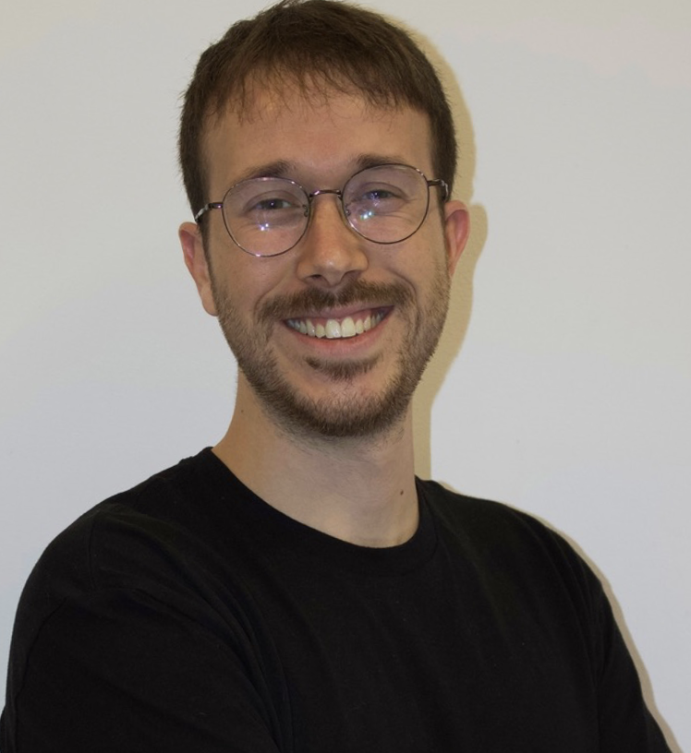
תמונה שלי:

